**Upload from Nexus GUI:**

1. You can only upload artifacts through GUI if the repository policy is Release. First, Login to nexus <https://nexus.prod.cloud.fedex.com:8443/nexus>
2. Select the repo where you want to upload the artifact.

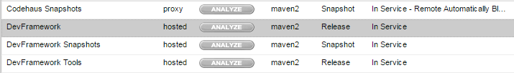

1. Now you will get a window with three tabs. Select **Artifact Upload** tab.

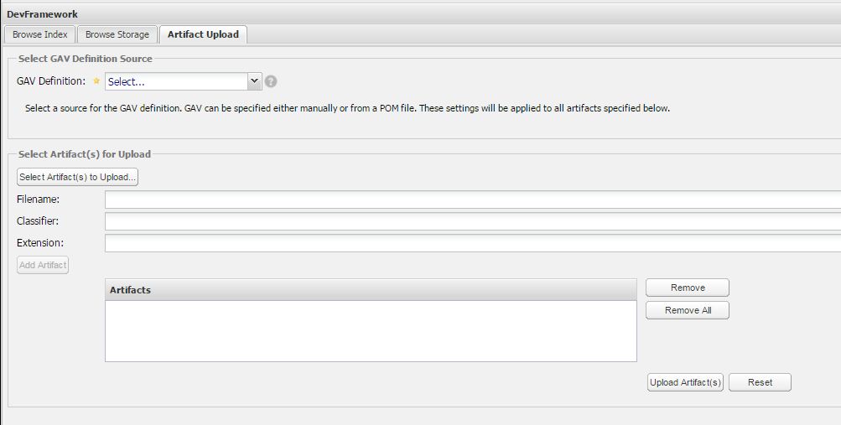

1. Under the **GAV Definition** you can choose either to upload the POM or use GAV (GroupID, ArtifactID, VersionID) parameters of the artifact.

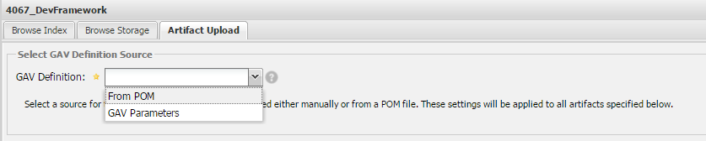

1. Below options will appear when you select GAV parameters option in the GAV Definition.

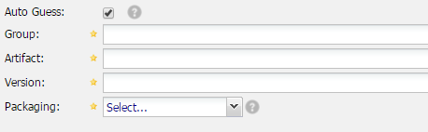

1. Use **Select Artifacts to Upload** button to choose artifacts from your local machine. If the artifact was built by maven, it automatically gets the Artifact name, version and packaging details. If you want to change the GAV parameters, you can change it to any name.

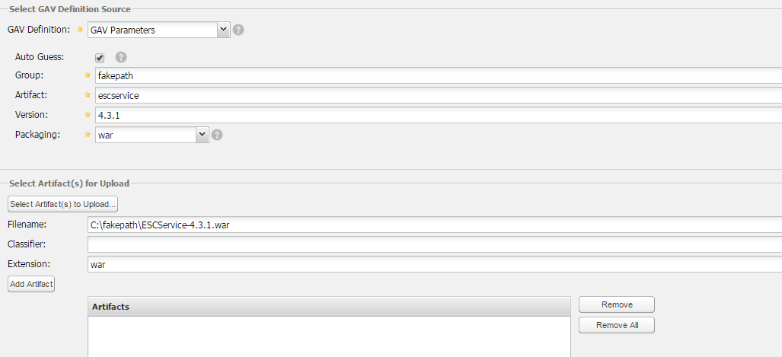

1. Just to give an example on directory structure of the artifact stored under the repo **DevFramework Tools.** Use the below screenshot as a reference**.**

**GroupID**: framework.mobileframework.Android

**ArtifactID**: androidlogging

**Version**: 1.0.0

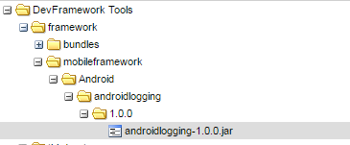

1. When you select **Add Artifact** your artifact will be added under artifacts group. Now, use Upload Artifacts button to upload the artifact to your repo.

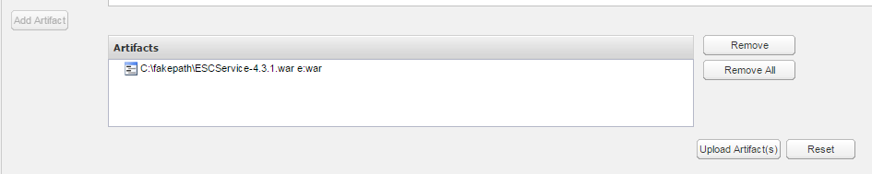

1. If you want to get the dependency information for the Artifact you uploaded, just select the jar file.

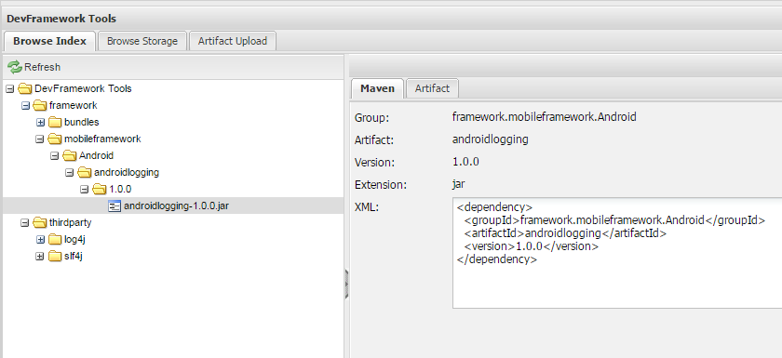

1. For more information use the below link

<https://books.sonatype.com/nexus-book/reference/using-sect-uploading.html>

**Programmatically upload an artifact to Nexus:**

There are multiple ways you can programmatically upload an artifact to nexus, use the below link to get more information on each of these.

### Direct Deploy

### Maven "deploy-file" Deployment

### REST API Upload

<https://support.sonatype.com/hc/en-us/articles/213465818-How-can-I-programatically-upload-an-artifact-into-Nexus->

**Deleting artifact:**

1. If you would like to delete an artifact through GUI, select the repo where your artifact resides. You will get a window with three tabs just like we get while we upload an artifact. Now navigate down to the artifact that needs to be deleted and select it.

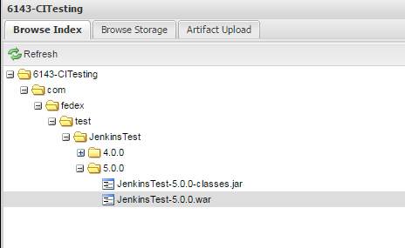

2) You will get an other window to the right with two tabs. Select the **Artifact** tab and now you would be able to see the **Delete** option.

